**PROJECT DEPLOYMENT AND PROJECT DEVELOPMENT**

**Login page in android:**

Once we open the app it will display the login page we can login with already registered credentials. In our app we have two modules 1. Police module and 2. Public module Based on our login mail address it will take to their respective modules.

If we give mail address like @police.com it will take to the police module

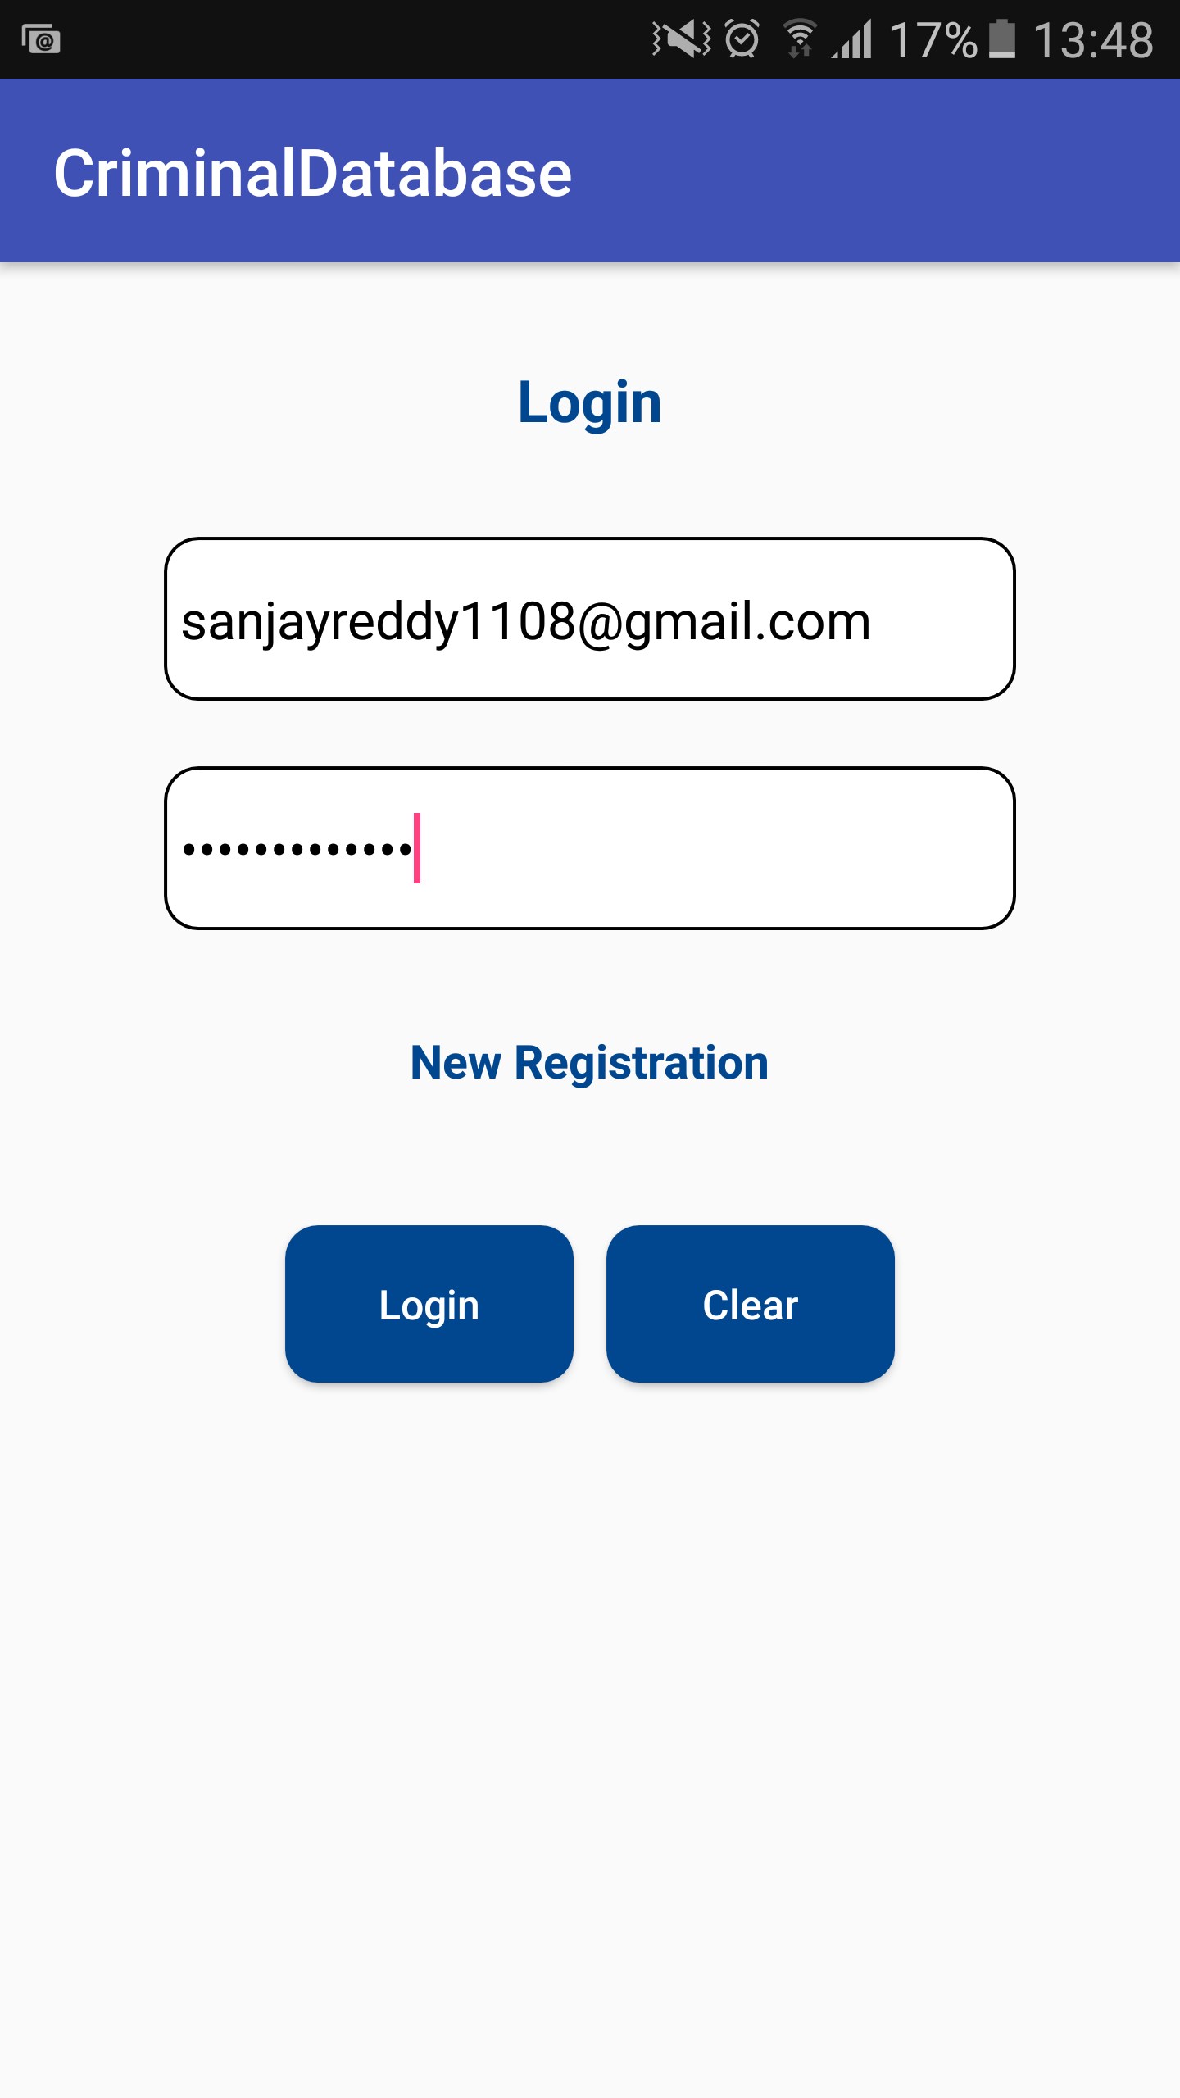

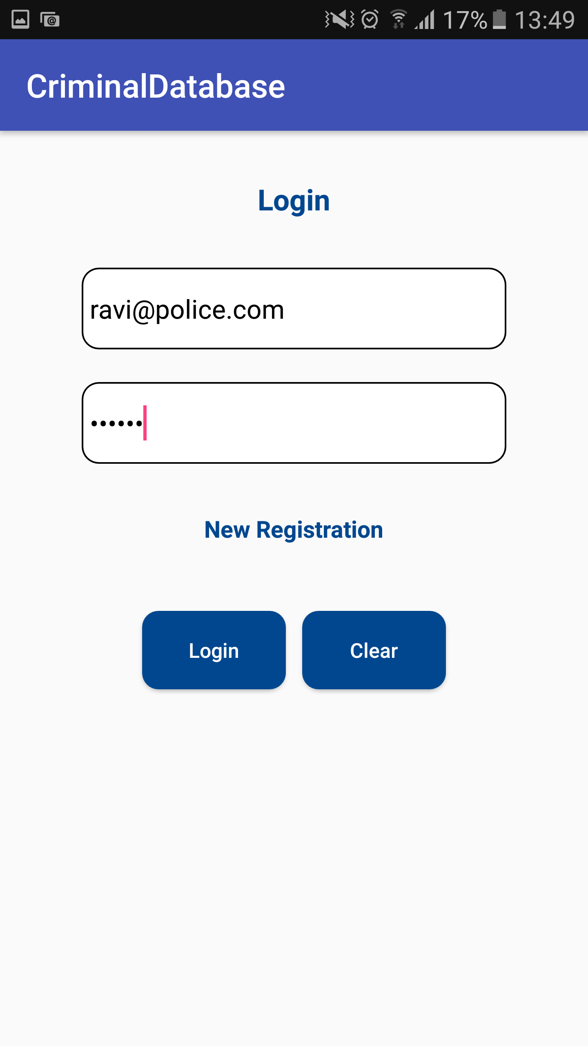

Registration page in the android application:

Once we click on registration page on sign in page we will get the signup page we can signup with our details

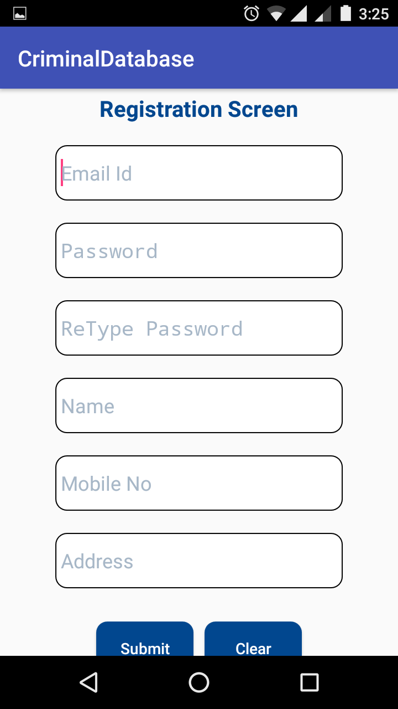

Police module home page:

Once we login with police credentials we get the police module homepage

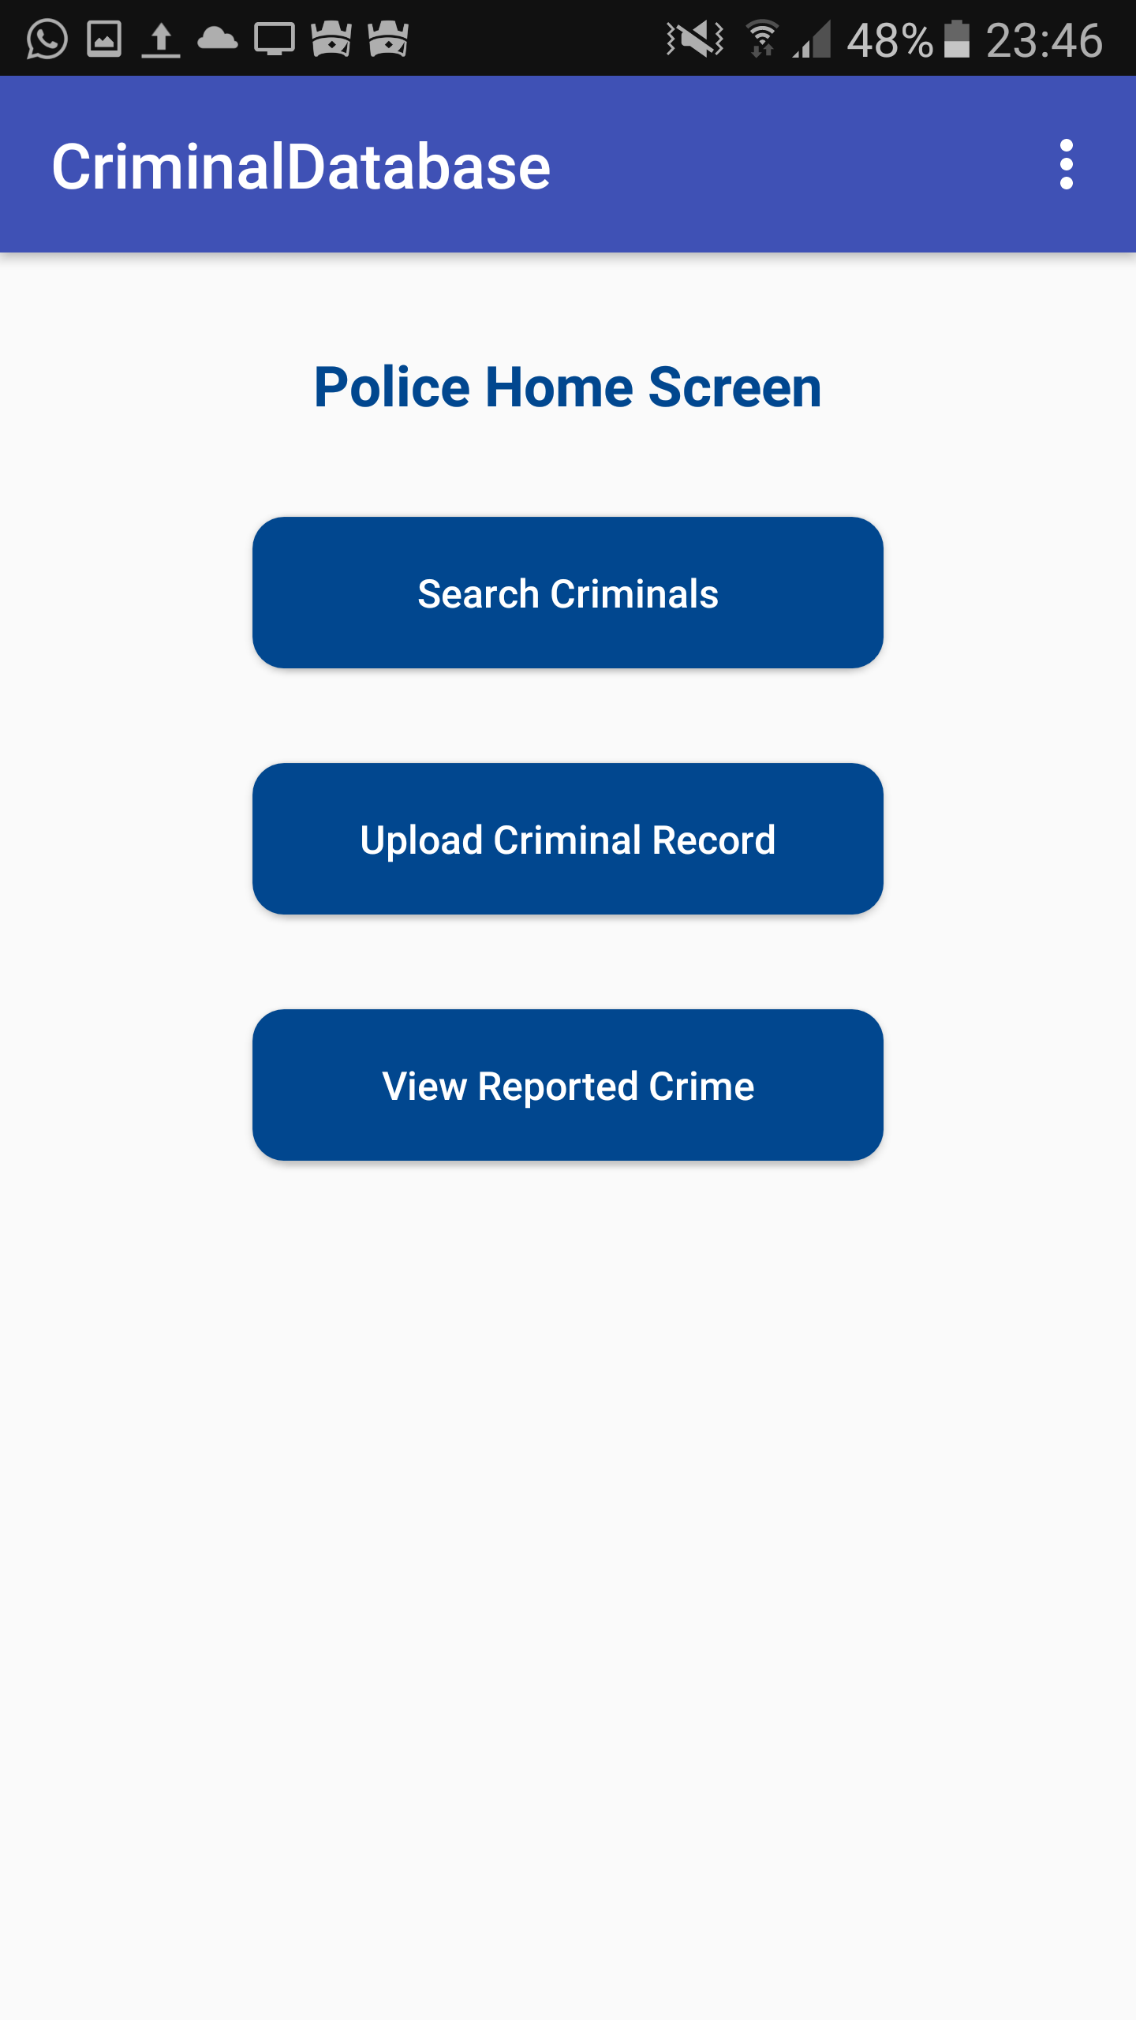

Search criminals in police module:

If police want to add a criminal first he need to check whether we have already this criminal or we can search a criminal for his crime record

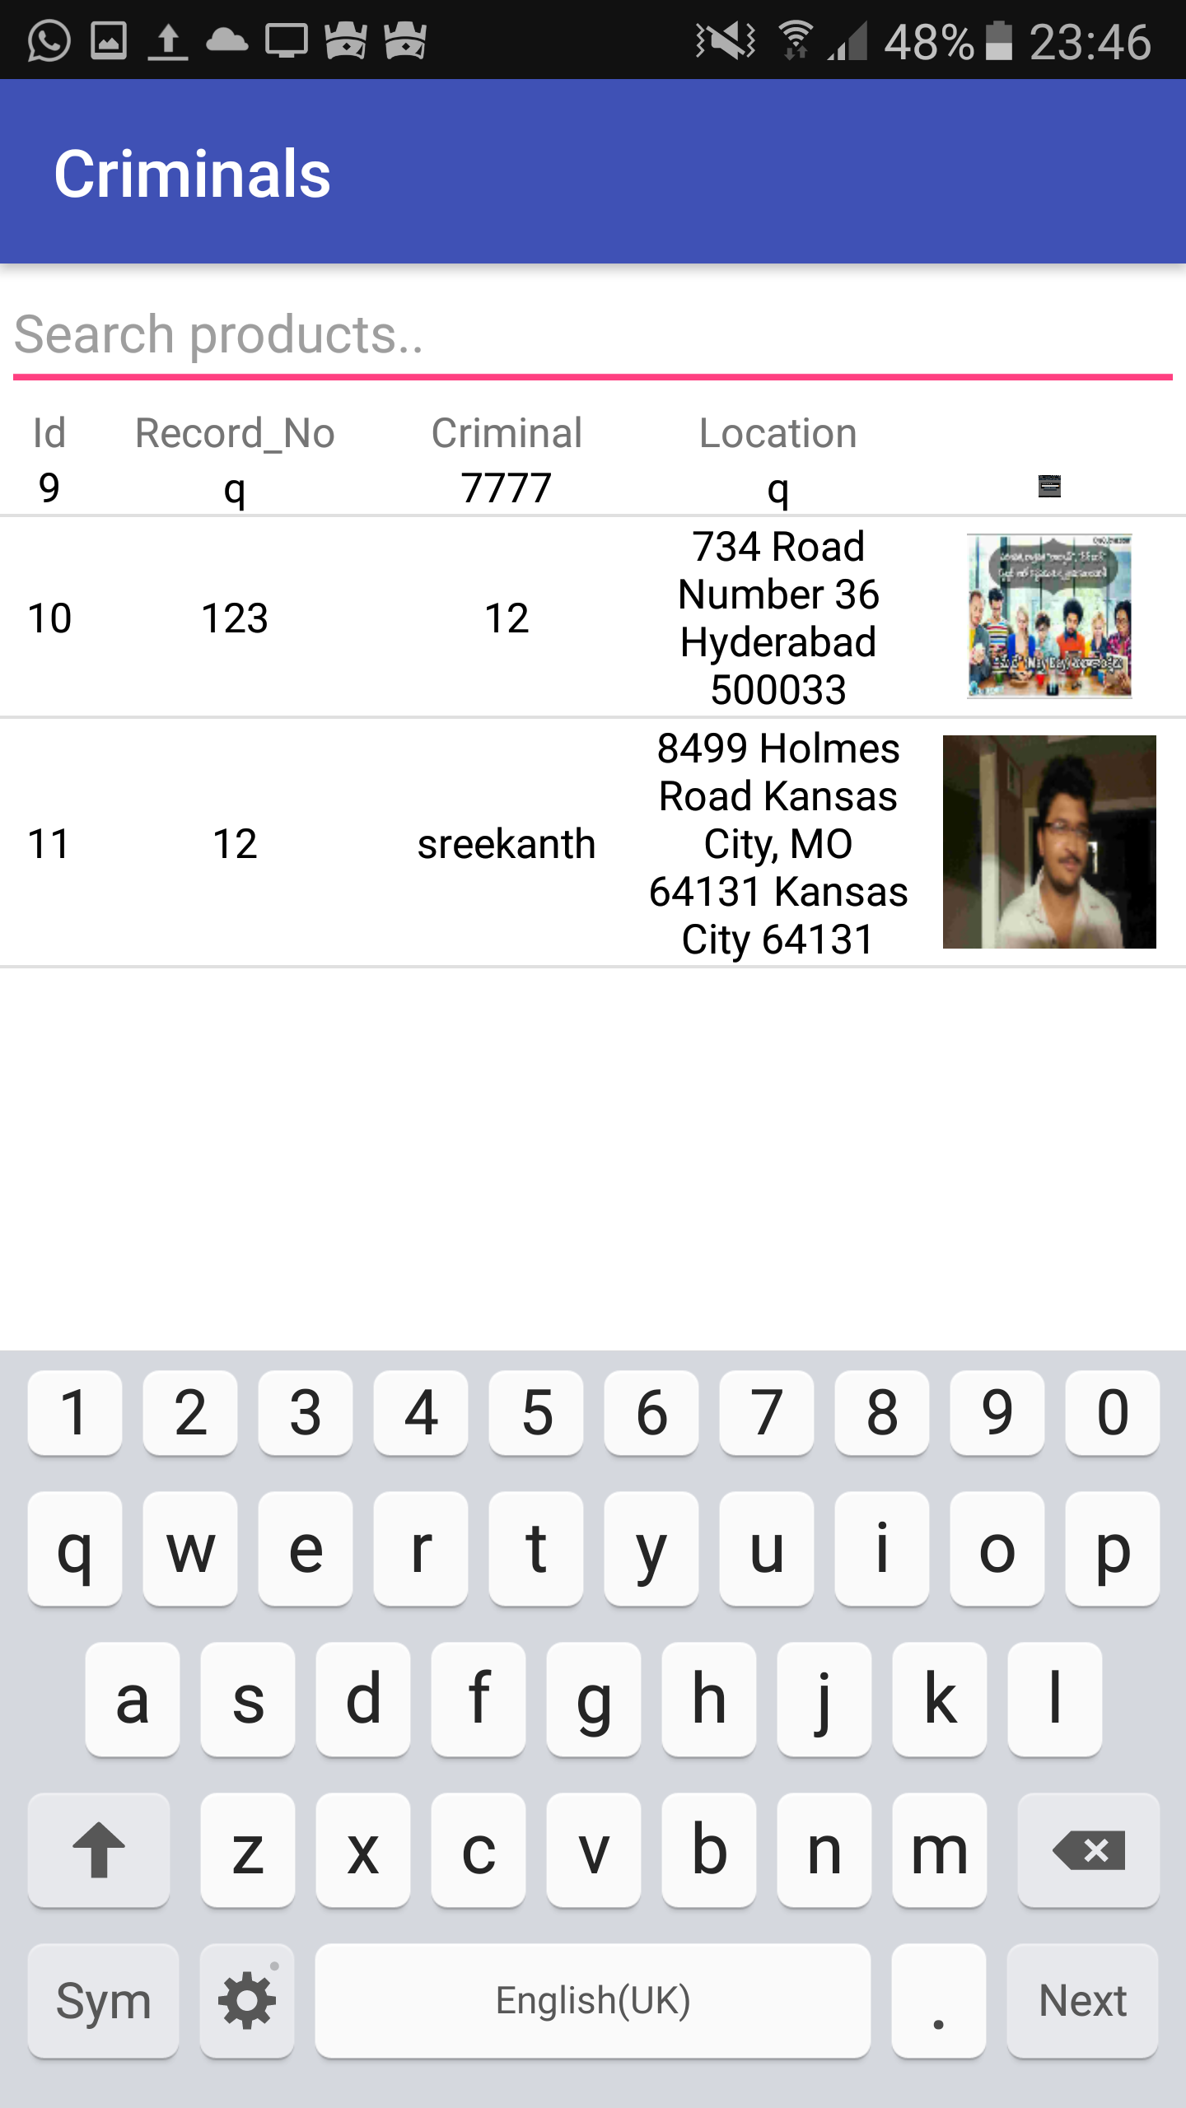

Upload criminal record:

If we found a crime then police can upload the crime. We can give criminal image and crime location also

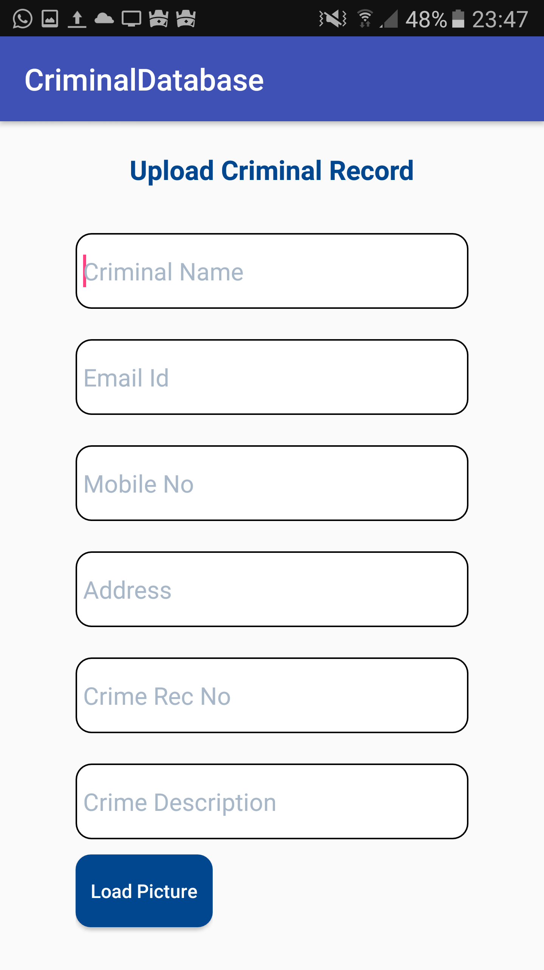

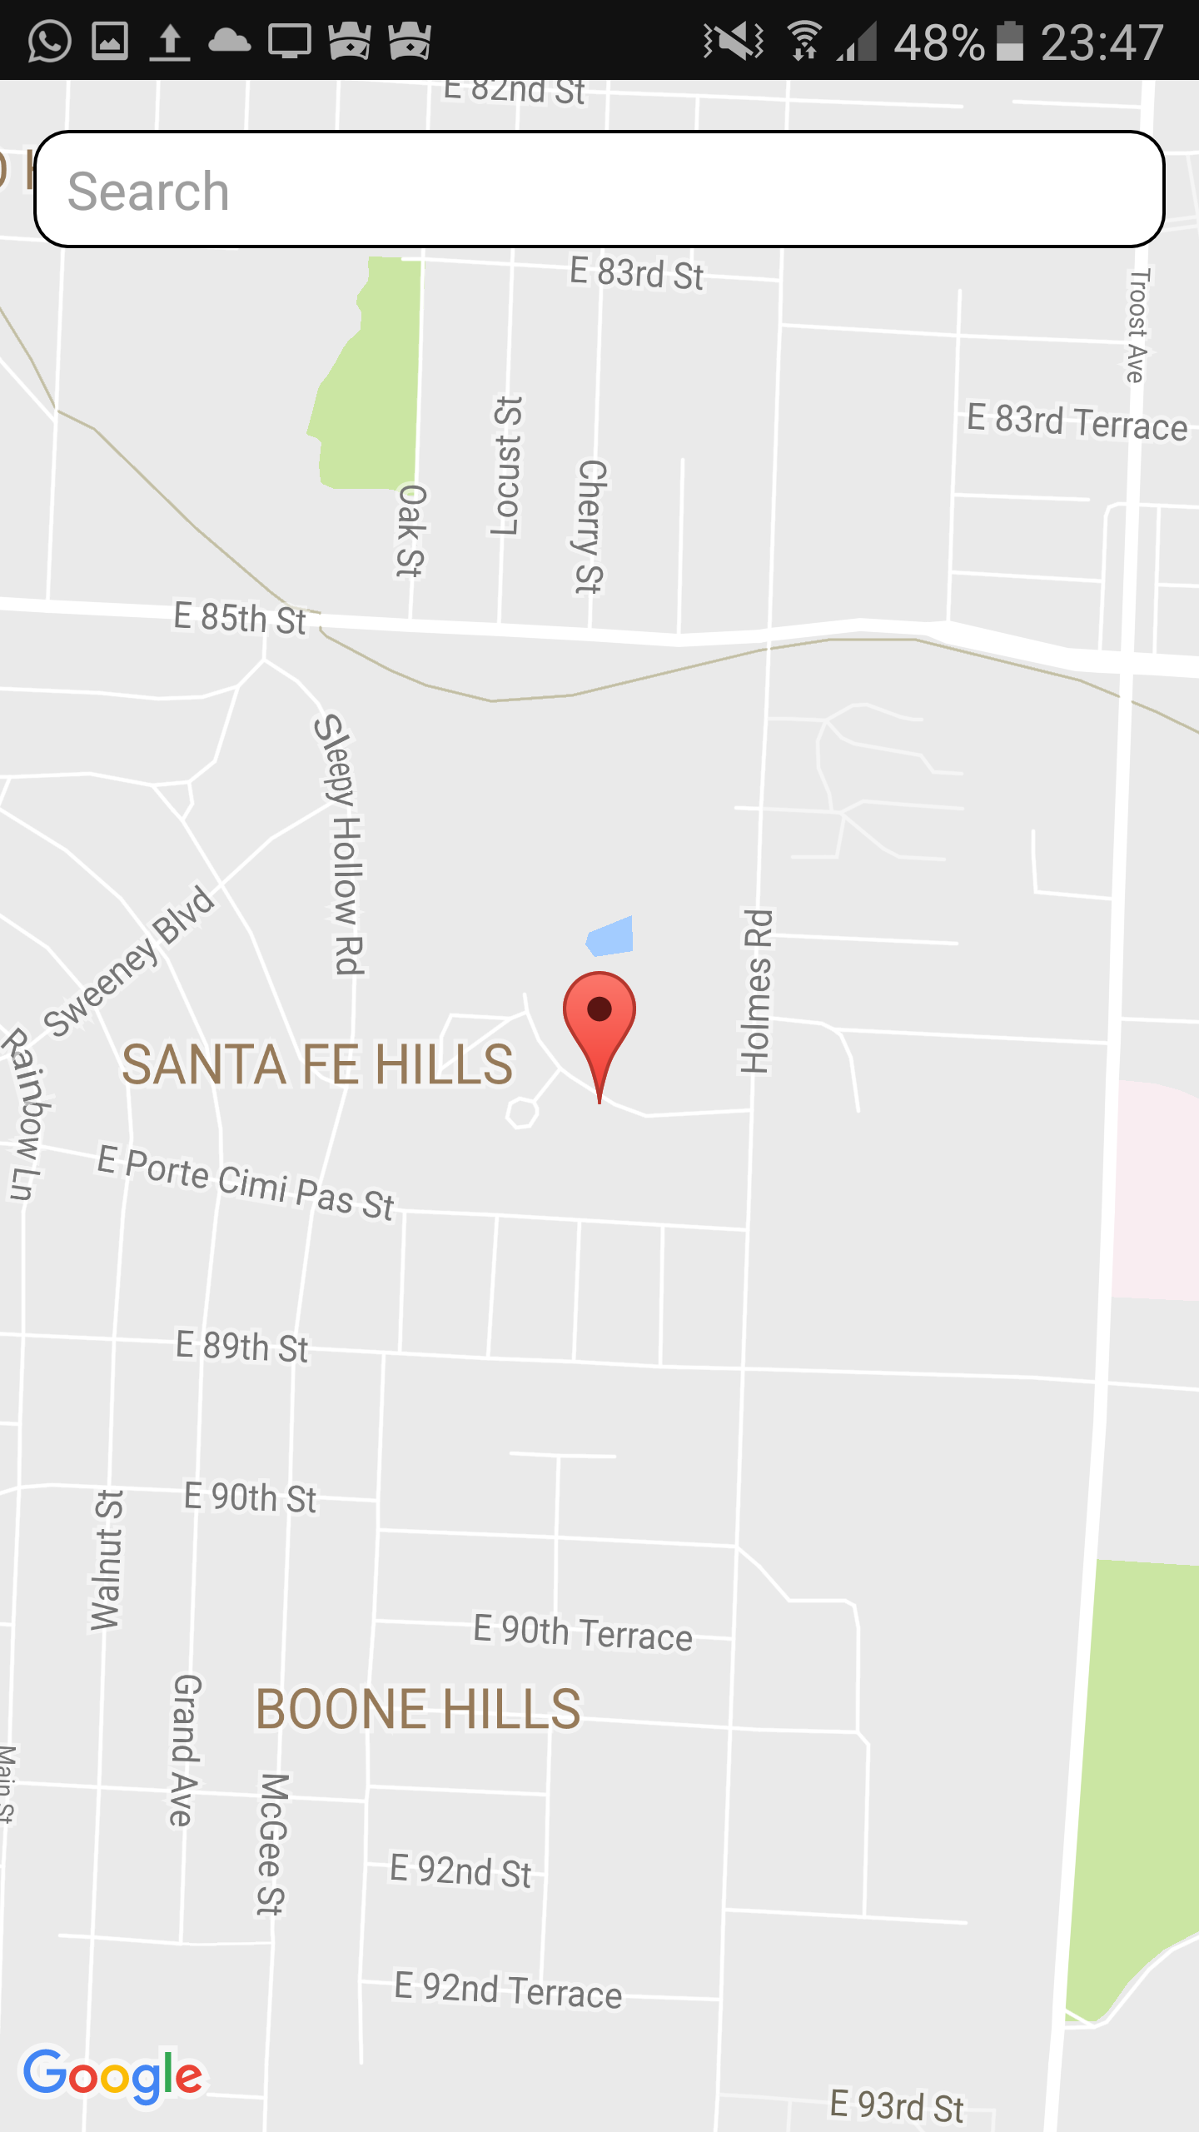

View reported criminals:

If some public report a criminal then he can see the reported criminals in this page

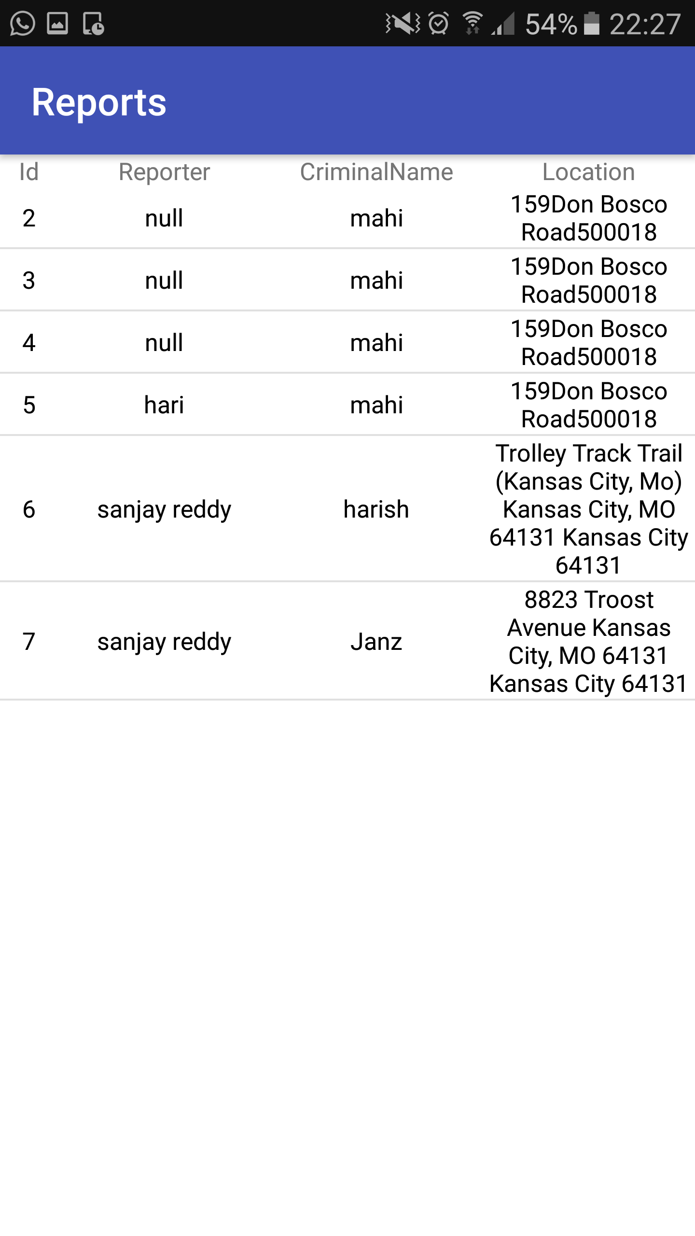

Public module Home page:

Once we login with public user credentials we can see the public module home page. It has report a criminal option and emergency buuton.

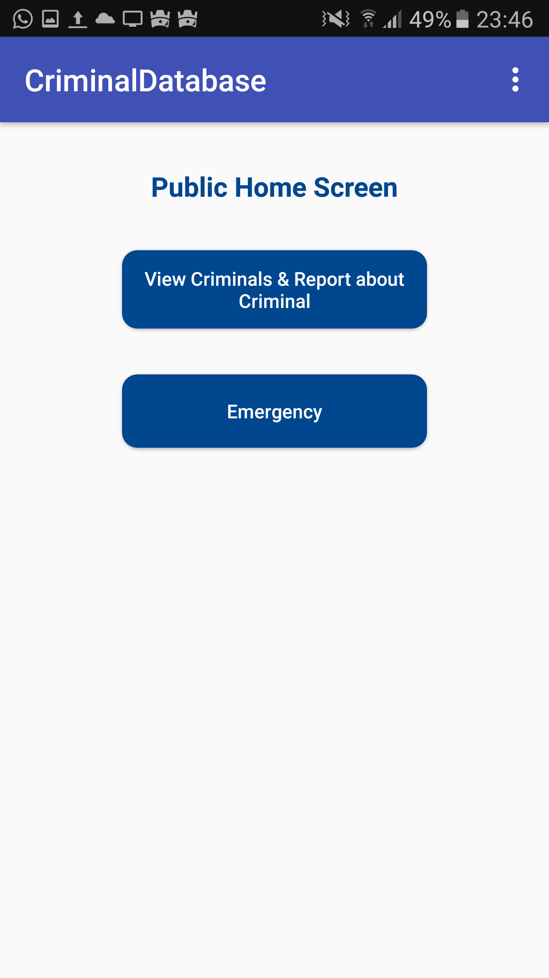

View criminals and report a criminal:

Once we click on we can see the criminals and if we come across a criminal we can report about the criminal.

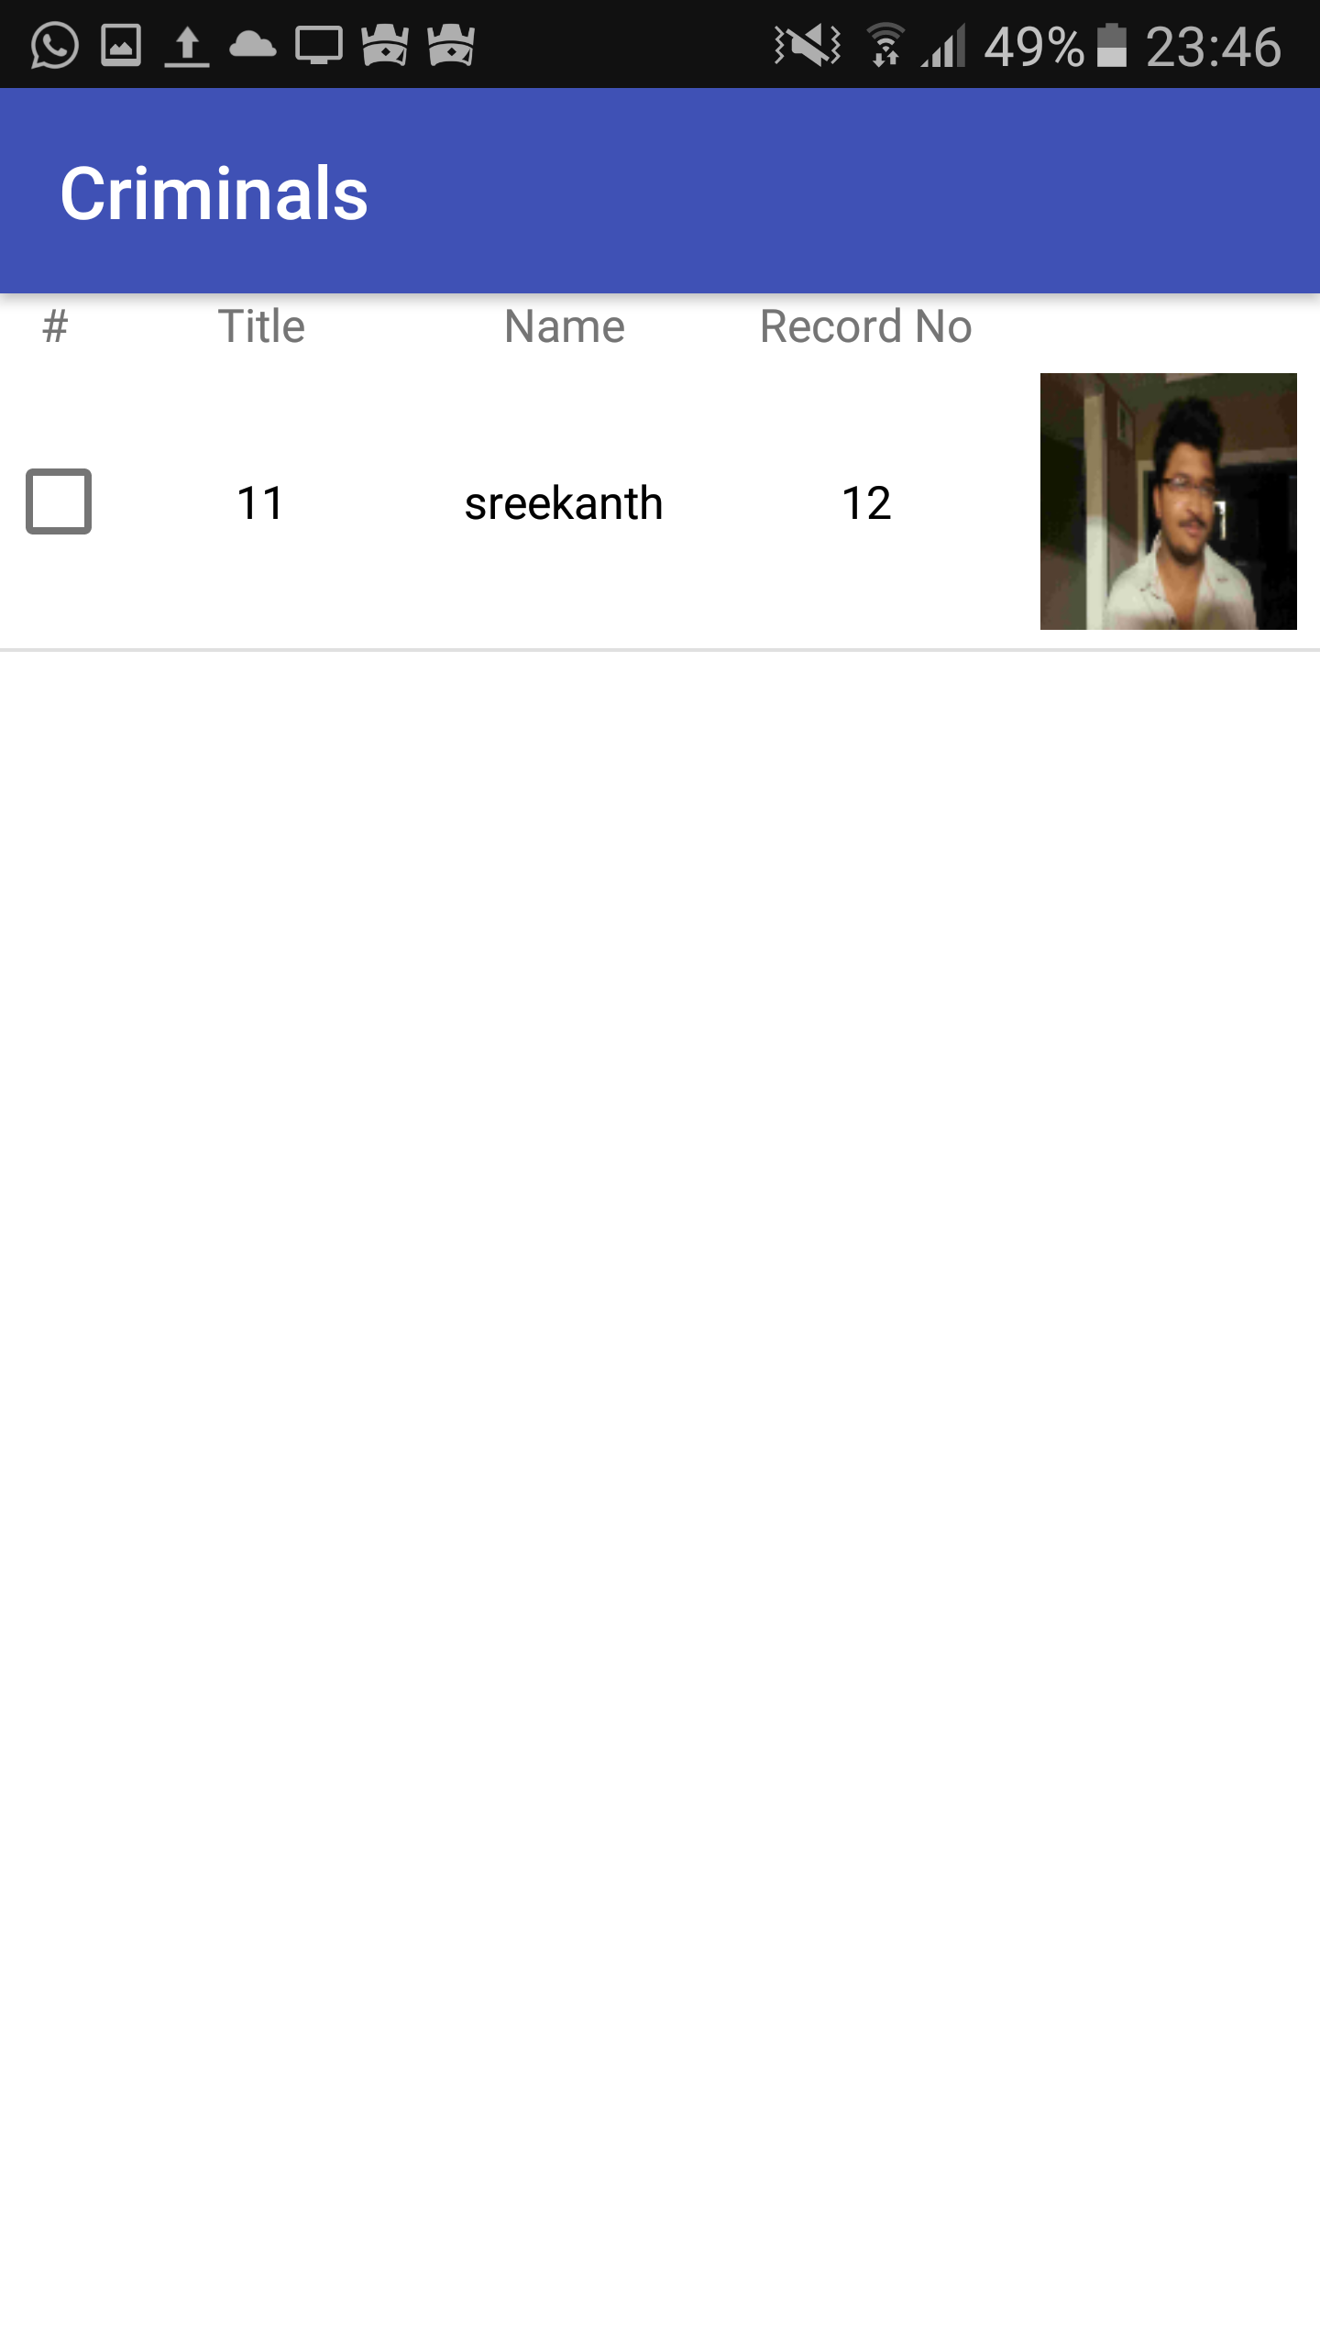

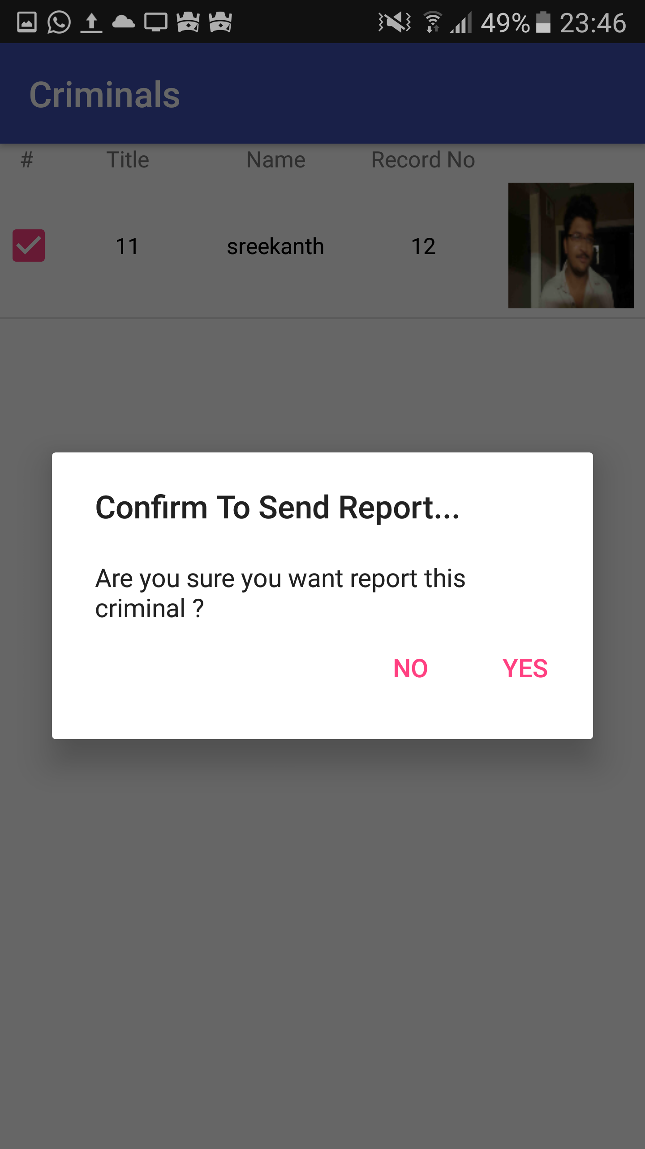

Emergency button:

If we click on emergency button a notification will be send to all the cops. Who is near by police he will go there

